**Letter to Mr. Peter Knight Re: Public Meeting for the Negril Breakwater Project, November 10, 2014 – Time To Submit Our Comments**

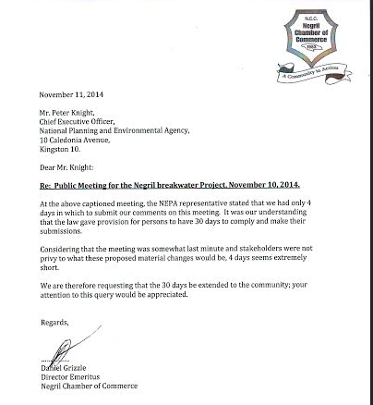

**Mr. Peter Knight’s Response to above Letter from the Negril Chamber of Commerce:**

From: Knight, Peter [mailto:Peter.Knight@nepa.gov.jm]   
Sent: Tuesday, November 11, 2014 5:53 PM  
To: Sophie Roumel  
Cc: Smith, Thamani; Chambers, Marie; Henry, Ainsley; Bedasse, Aisha  
Subject: FW: Time on NWA Presentation re Breakwater Project  
Importance: High

 Ms Roumel

 The Negril Chamber of Commerce is to be advised that the 30 days is an allowance included in the NRCA guidelines. It is not a stipulation in law. There is no determination of the days allowed for follow-up meeting/s. For the matter before you yesterday the time allotted is reasonable.

Regards,

Peter G. Knight, JP  
Chief Executive Officer/Government Town Planner   
National Environment & Planning Agency (NEPA)  
10 Caledonia Avenue  
Kingston   
Telephone:  St. Line (876) 754-7526  
Mobile: (876) 995-4546;  (876) 354-0328  
Fax: (876)754-7594  
Email: nepaceo@nepa.gov.jm; peter.knight@nepa.gov.jm

**Negril Breakwater Project Stakeholders Comments to Mr. Peter Knight**

November 11, 2014  
  
Mr. Peter Knight,  
Chief Executive Officer,  
National Environmental Planning Agency  
10 Caledonia Road  
Kingston 10.

Dear Mr. Knight:

Re: NWA Presentation on the Proposed Breakwater Project.

First we would really like to say a big thank you to the National Works Agency for coming out, prepared for this meeting and ready to start on time. Our complaints from previous meetings were heard and taken into consideration – well done NWA!

We also have to say that the choice of Chairperson was excellent – Mr. James was a fair and unbiased Chair. He kept the meeting in order and based on his contribution, it was clear he had prepared and did some research into this project and breakwaters in general.   
  
It was also noted that the “reserved” seats in the front were all empty. Perhaps these were intended for the missing in action members of the Planning Institute of Jamaica and the engineering team CEAC Solutions.

The agenda was cut short at our request, as we had no desire to sit through yet another presentation of the project – we have all heard it before and came to hear about the changes being considered.

The handouts left a lot to be desired, as the size of the diagrams was too small and virtually impossible to read. The content of some of the boxes could only be described as “amazing”. Not sure who is responsible for this document but they claim these breakwaters will result in an average shoreline growth of 13.5 meters per annum in Long Bay. If this is not an unfortunate typographical error, then perhaps the mistake is that the Negril community has been perceived as a dimwitted bunch. We wonder where the 109,400 cubic meters of sand to accrete over 80% of Long Bay will come from? It is a well-known fact that the sand production of Negril is extremely low.

The material changes we came to hear were simple: the river would not be dredged and the construction site/storage area would be removed at the end of the project. We were delighted to hear about the river, however it was never our only concern. The plan is still to dump up the area south of the jetty with sea sand and now with suitable material from a quarry – this proposal is still unacceptable. Dumping up will change the natural beauty of the coastline and disrupt the fish, turtles and birds that feed in this area daily.

The site will also become a major eyesore in a resort town and result in traffic congestion. While we were assured by the NWA that this would be restored to what is there now, we have no confidence that this would be true. The record shows that at other projects, for example Palisados, nothing has been put back to what it originally was and the contractors have gone leaving a mess behind. Why would we expect that this site would be any different? Furthermore, as it would be at the end of the project, we can hear it now “the money done – sorry!”.

It is a pity that the invitation to come to the presentation by Deltares was refused as a new way of thinking and working with Nature was shown. The Netherlands is the world leader in coastal protection, as 26% of their land is below sea level. The Dutch are moving away from hard structures to protect their coastline and their coastal engineers have assured us that a breakwater cannot address rising sea levels. However, beach nourishment can. If these structures are built and do not function, who will remove them and at what cost? Who will be responsible for maintaining them?

Again this brings us to the hard truth that there are no coastal engineers on this team who designed these breakwaters – a major concern and defect of this project that is expected to fight beach erosion.

We would like to appeal to NEPA to reconsider this project and turn it down. The majority of the community is against it and do not want building of any hard structures to combat beach erosion. The natural beauty of Negril will be destroyed and it will be the death of tourism.

All our concerns from our previous letter dated August 12, 2014 on this issue still stand.